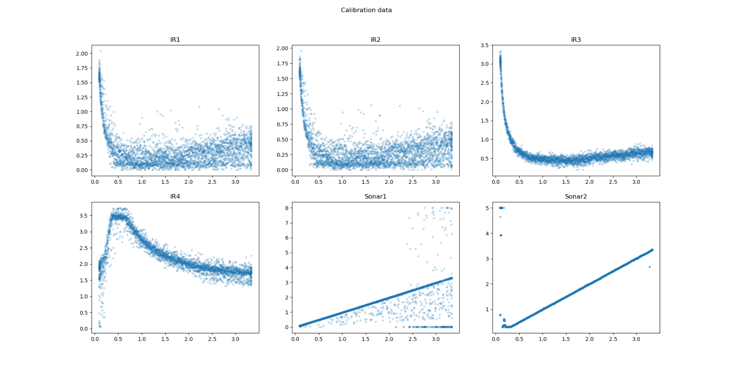

Need to select 3, factors:

* Best performance (minimal noise)
* Covers range of distances.
* Sonar 2, minimal noise but shonky below 0.3m.

<https://www.maxbotix.com/documents/HRUSB-MaxSonar-EZ_Datasheet.pdf>

* IR3 is good from 0.1-0.8 m.

<https://www.sparkfun.com/datasheets/Components/GP2Y0A21YK.pdf>

* Sonar 1, noisier than 2 but better low range.

<https://cdn.sparkfun.com/datasheets/Sensors/Proximity/HCSR04.pdf>